Peterhead AAC
Update 9 2004

Cross Country races (2003/2004)

Inverness league, 10 Jan 2004

1st R. Arbuckle 35-48, 2nd Alan Reid 36-08, 3rd B. Fieldsend 36-19, … 32nd Iain Cruickshank 43-24

Forres league, 31 Jan 2004

1st R. Arbuckle 33-50, 2nd Alan Reid 34-05, 3rd A. Clark 34-23, .. 26th Iain Cruickshank 39-45, … 34th Andy Newlands 42-32, …

Moray league, 14 Feb 2004

1st R. Arbuckle 33-42, 2nd Alan Reid 34-20, 3rd B. Fieldsend 35-06, … 18th Iain Cruickshank, …

Cross Country races (2004/2005)
Ross County League, 2 Oct 2004
1st K Greig 37-02, 2nd A Clark 38-02, 3rd R Arbuckle 38-40, … 21st Iain Cruickshank 45-39, … 38 ran

Elgin league, 30 Oct 2004

1st R. Arbuckle 35-57, 2nd R. Milne 36-14, 3rd A. Clark 36-48, … 25th Iain Cruickshank 42-33

Nairn league, 13 Nov 2004

1st K Greig 33-36, 2nd A Clark 34-06, 3rd B Fieldsend 43-21, … 23rd Terry Christie 37-46, … 35th Iain Cruickshank 40-37, …

District Championships, Inverness
1st B Livesey 35-28, 2nd A Clark 35-47, 3rd K Greig 35-57, 4th Alan Reid 36-44, … 36th Iain Cruickshank 43-13, 42nd Andy Newlands 47-03, 49 ran

Relays, Forres 16 Oct 2004
1st Moray 59-39, 2nd Forres 60-02, 3rd Inverness 62-22
….. 6th PAAC 66-10 (Peter Robertson 18-28, Terry Christie 15-49, Iain Cruikshank 17-03, Alan Reid 14-50) Fastest K. Greig 14-08, 3rd Alan Reid

10 milers

Elgin games 10 miles, 17 July 2004
1st S Pride 53-28, 2nd Darren Strachan 56-45, 3rd J Goodall 58-11
Abernethy 10 mile road race,
1st A Ross 59-10, 2nd R McLennan 59-10, 3rd M Howell 59-40, .. 68th John Diffey 88-45, 84 ran

Dundee 10 miles, 7 Nov 2004
1st D Knight 54-59, 2nd M Carroll 56-06, 3rd N Cunningham 57-44, … Duncan Lynch 80-42

Lossiemouth ‘turkey trot’ 10

1st Alan Reid 55-07, 2nd J. Lenehan 55-51, 3rd B. Foreman 56-03, …. 28th Iain Cruickshank 63-53, … 86th John Diffey 78-43, 121 ran

Northern 10K series

Nairn 10k,

1st G. Bee 32-23, 2nd A. Wright 32-27, 3rd J. Whittet 34-01,
20th Iain Cruikshank 38-18, … 65th John Diffey 42-35, …
239 ran

Moray 10k, 28th March 2004

1st B. Fieldsend 32-41, 2nd G. Bee 33-09, 3rd R. Milne 34-22,
… 18th Iain Cruickshank 38-31, … 93rd Duncan Lynch 46-20, … 140th Ann Smith 51-41, … 184 ran

Forres 10k, 15 May 2004

1st S. Pride, 31-29, 2nd G. Bee 32-36, K. Farquahar 32-53, … 34th Iain Cruickshank 38-20, … 45th Peter Robertson 40-07, … 170th Ann Smith 50-34, …219 ran

Half Marathons

Inverness half, 14 March 2004

1st S. Pride 69-33, 2nd B. Fieldsend 72-27, 3rd E. Riddle 72-33, … 208th John Diffey 95-58, … 896 ran.

RAF Kinloss-RAF Lossiemouth Half

1st S. Pride 64-54, M. Paddon 72-26, J. Gartside 72-55, … 85th John Diffey 94-55, … 193 ran

Aberdeen AAC half 2004

1st B. Hukins 69:29.5, 2nd R. Campbell 70:55.3 3rd G. Bee 73:07.8, … 56th Duncan Lynch 99:54.3, … 83 ran
Skye half, June 2004
1st S Gibson 75-24, 2nd J Gavelle 80-00, 3rd D Wright 80-01 … 23rd Peter Robertson 93-04 … 183rd Elaine Booth 137-36, 213 ran.
Stonehaven half, 4 July 2004
1st A Derrick 73-47, 2nd R Campbell 74-112, 3rd Darren Strachan 75-21 …. 245 ran.
Dyce half, 1 Aug 2004
1st K Farquhar 73-28, 2nd Darren Strachan 76-30, 3rd P Hay 78-31, … 60th Duncan Lynch 104-13, 95 ran
Moray half, 29 Aug 2004

1st E. Riddle 75-43, 2nd J. Mathieson 77-52, 3rd Darren Strachan 77-58,…. 126th Duncan Lynch 105-47,…

Fraserburgh half,

1st K. Tulloch 80-08, 2nd K. King 81-23, 3rd S. Andrew 82-13 , … 57th Duncan Lynch 106-06, 108 ran.

10k races
Longside 10k, 22 May 2004
1st K Farquhar 33-02, 2nd Darren Strachan 34-26, 3rd C Noble 35-20, .. 6th Terry Christie 37-07, . 8th John Robertson 37-30, . 10th Iain Cruikshank 38-09, .. 29th Ian Duguid 44-27, .. 32nd Duncan Lynch 45-06, . 37th Paul MacDonald 47-51, …

Aberdeen Baker Hughes 10k, 23 May 2004

1st S. Pride 30-59, 2nd M. Carroll 31-36, 3rd G. Bee 32-15, … 55th Iain Cruickshank 38-01, … 67th Peter Robertson 38-32, … 192nd Andy Parkin 42-42, … 261st Duncan Lynch 43-55, … 433rd Jamie Mundie 46-12. 1000+ ran.

Aberdeen Beach 10k, 15 June 2004

1st M Beattie 34-15, 2nd J Whittet, 3rd G Riddell 35-42, … 22nd Peter Robertson 40-35, … 83 Ian Duguid 46-32, 255 ran

Fraserburgh 10k, 20 June 2004

1st Darren Strachan 34-40 … 9th Peter Robertson 39-25, 20th Roger Curtis 41:19, .. 35th Ian Duguid 44-50, … 42 Duncan Lynch 46-02.

Forres Highland Games 10k, 10 July 2004
1st G Bartlett 32-33, 2nd F Barton 34-27, 3rd Darren Strachan 34-55

Fishie 10k, 8 Aug 2004

1st M. Beattie 35-00, Darren Strachan 35-30, 3rd C. Noble 36-43, … 31st Ian Duguid 45-06, … 38th Duncan Lynch 46-47,… 52nd Ann Smith 51-01, … 72 ran.

Moray 10k, 29 Aug 2004

1st F. Barton 33-59, 2nd K. Farquhar 34-00 , 3rd Alan Reid 34-00, … 300 ran.
Peterhead 10k, 5th Sept 2004
1st D Wright 32-24, 2nd Alan Reid 34-28, 3rd D Duguid 35-02, … 2nd vet Iain Cruickshank 39-29.

Buckie 10k, 19 Sept 2004
1st F Barton 32-57, 2nd K Farquhar 32-59, 3rd K Cowie 33-43, … 12th Terry Christie 37-08, … 21st Iain Cruickshank 39-23, … 60th Duncan Lynch 43-36

Marathon or longer

Speyside way 50k, 11 April 2004

1st S. Pride 3-02-15, 2nd = A. Eccles 3-24-11, 2nd = N. Hall 3-24-11, 56th John Diffey 4-58-21... 94 ran

Lochaber marathon, April 2004

1st S Pride 2-21-21, 2nd S Gregory 2-35-59, 3rd A Merdes 2-37-50, … 222nd John Diffey 4-01-44, 294 ran.

Edinburgh, 13th June 2004

1st J Mutai 2-21-45, 2nd E Kiplagat 2-21-55, 3rd T Abyu 2-23-04, … 739th Duncan Lynch, 3-57-27

Track

East District Championships, 15 May 2004

400m 1st B Middleton 49.71, 2nd B Gibb 50.15, 3rd John Dunlop 50.49s

Scottish Championships, 14/15 July
400m 1st J Deacon 46.96, 2nd A Low 48.63, 3rd A stuart 48.91, 4th John Dunlop 49.17s (heat 48.74).

Off Road Events

Culbin Forest run, 26 May 2004

1st G Bartlett 27-24, 2nd B Fieldsend 27-51, 3rd A Clark 28-19, … 37th John Diffey 34-31.

Ben Aigen Hill race, 6 June 20004

1st G. Bartlett 29-29, 2nd A. Clark 30-50, 3rd A. Smith 30-58, … 20th John Diffey 40-48, … 34 ran

Metro Aberdeen prom 4 mile, 9 June 2004

1st K Farquhar 21-06, 2nd K Tulloch 21-36, 3rd C Stewart 21-48, … 13thPeter Robertson 24-46, … 25th Ian Duguid 27-14,… 32nd Duncan Lynch 28-23, 66 ran

Roseisle Woodland Run, 9 June 2004

1st G Bartlett 21-24, 2nd R Arbuckle 21-39, 3rd E McCarthy 21-55, … 39th John Diffey 27-35

Quarrelwood woodland run, 23 June 2004

1st P Rogan 24-21, 2nd D Adam 24-27, 3rd M Mitchell 24-35, … 19th James Ward 28-38, 94 ran.

AAAC, Balgownie Open, 7 Nov 2004
1st K. Farquhar 33-56, 2nd C Davidson 33-56, 3rd M Beattie 34-12, … 14th Iain Cruickshank 41-00, 25 ran.

White Cow woods, 26 Dec 2004

5k 1st C. Noble, 2nd B Dallas, 3rd Sandy Hastie 22-29

Beach Run, Peterhead to Fraserburgh, 2004
1st Darren Strachan 1-46-30, 2nd S Buchan 2-00-38, 3rd G. McRobbie, 4th J Bowie 2-05-22, 5th M Harper 2-06-10, A Mathers 2-07-37, 1st female S Milne 2-37-18

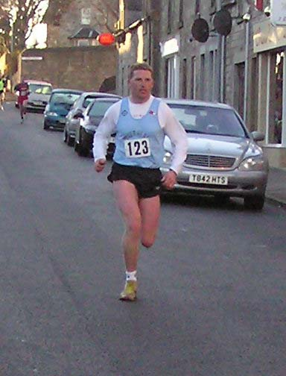
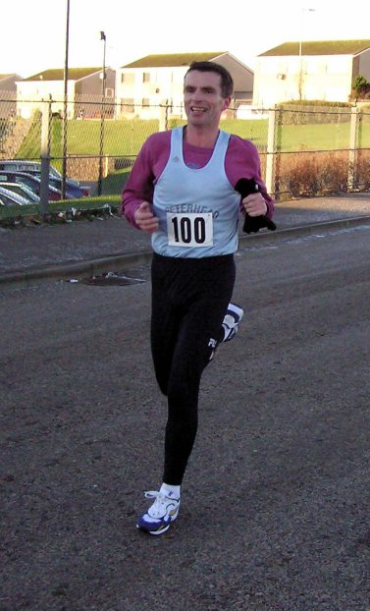
Alan winning the ‘turkey trot’
Iain also ‘trotting’!

Season bests

 | 10k | 10 mile | half marathon | marathon
Iain Cruickshank | 38-01 | 63-53
Terry Christie | 37-07
Ian Duguid | 44-27
John Diffey | 42-35 | 78-43 | 94-55 | 4-01-44
Sandy Hastie
Jamie Mundie | 46-12
Andy Newlands
Andy Parkin | 42-42
John Robertson | 37-30
Peter Robertson | 38-32 |  | 93-04
Alan Reid | 34-00 | 55-07
Darren Strachan | 34-26 | 56-45 | 75-21
Stuart Scott
Ann Smith | 51-01
Duncan Lynch | 43-36 |  | 99-54 | 3-57-27
Paul MacDonald | 47-51

John
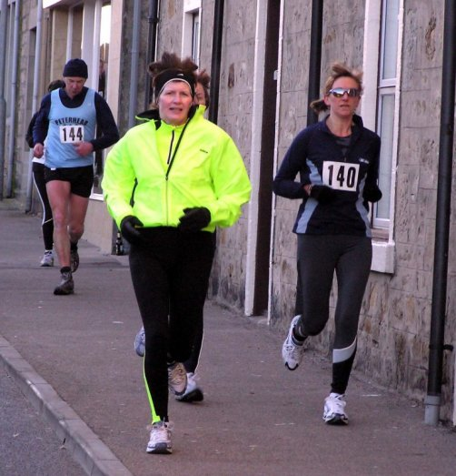
John running for his Xmas dinner!
P.S. Sorry if I missed that ‘magic’ run

