Peterhead AAC
September- Update 4 Autumn 2000

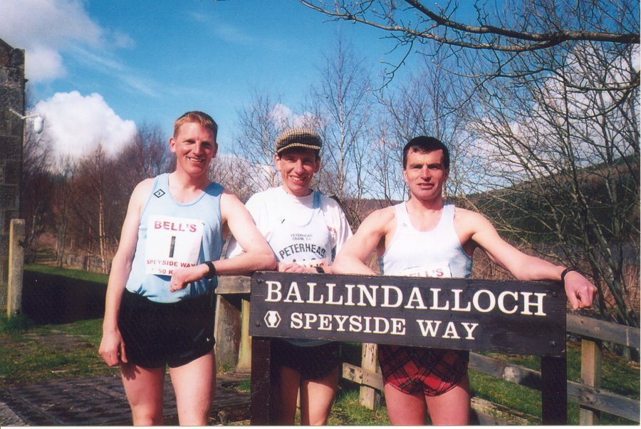

Track Events

Only John Dunlop and Shona Mackinnon ventured onto the track this season.

Shire Open meeting
800m 1. S Mc Allister 1-58.9….John Dunlop 2-01.9
At the Drumnadrochit John competed in 8 events winning five of them!
Ian Cruickshank daughters won at the Cornhill races (U16 & U12) and collected more prize money than dad! Alan Reid was squeezed out by Frank Barton over the 3 ½ mile race (both 17-06) as Alan hit a post on the way round the field (his excuse not mine! Ed); Ian was 5th (20-33).

Anglo-Celtic Plate International 100k Road Race

Alan was leading at 50k but had a bad time between 60 –70k (53min) then rallied to run the last 10k in 47min. A great run to gain selection to run in Holland in a GB vest.

1. S Moore (Eng) 7-14-57, 2 Alan Reid (Scot) 7-27-24, 3.C Finill (Eng) 7-37-11.
Fixtures
North District League (as at 23/04/2000)
07/10/2000 Caithness AAC
11/11/200 Nairn & District
09/12/2000 Moray roadrunners
13/01/2001 Inverness Harriers
27/10/2001 Elgin AAC
10/02/2001 Forres Harriers

North District Cross country Relay

14/10/2000 ?

Road
01/10/2000 10k Buckie
01/10/2000 6 miles Forres
5/11/2000 10 mile Dundee Road Runners
12/11/2000 6 miles Aberdeen
Cross Country
05/11/2000 Hydrasun Races Balgownie, Aberdeen
16/12/2000 Interdistrict Cumbernauld

King’s Aquathon
John Diffey has taken to the water! He completed this 2 event competition (400m swim and 5k run)

Track nights

continued from page 1

Half marathons or 10 milers

Ballater 10, 30 July 2000

1. C Ross 56-41, 2 A Davis 57-32, 3 S MacGregor 59-13…. 8 Darren Strachan 61-05….19 John Robertson 63-08, 175 ran

Abernethy 10, 12 Aug 2000

1. P Matheson 56-14, 2 S McKenzie 56-54, 3 S Johnston 57-08….9 John Robertson 60-02

Portsoy 20k, 2 July 2000

Darren ran a good race giving it a real go over the last few miles. The times seemed to have been given 18s faster than wrist watches.

1 M Flynn 68-04, 2 E Riddle 68-13, 3 G Sim 68-18… 5 Darren Strachan 73-04…9 John Robertson 75-52…Ian Duguid 89-37

Stonehaven half, 2 July 2000
Alan was using this as a training run before his 100k so he waited until 8 miles before leaving Dan Whitehead, he even waited at the drinks station for him!

1. Alan Reid 74-37, 2 A Derrick 75-16, 3 D Whitehead 75-16

Nairn half, 20 Aug 2000

1. G Sim 73-43, 2 R Hardy 74-57, 3 C Noble 77-43…..7 John Robertson 80-35….9 Darren Strachan 82-30

Elgin half, 3 Sept. 2000

….9 Darren Strachan 78-34…11 John Robertson 78-47……. 48 Ian Duguid 93-28… 85 ran.

Season bests – half marathon

Alan Reid 69-30 Inverness
Darren Strachan 78-34 Elgin
John Robertson 78-47 Elgin
Ian Duguid 93-28 Elgin

Lochaber Marathon, Fort William

Both Alan and Gail suffered during this race and so didn’t run to expectations. Gail completed the Elgin marathon in a PB of 4-09.
1. D Rodgers 2-28-53, 2 N Maltman 2-38-40, 3 Alan Reid 2-40-32.

10k races

Balmoral 5miles, 22 April 2000

1. M Carroll 25-28 2 W Coyle 25-33 3 A Hart 26-11….. Darren Strachan …… Ian Duguid 35-29

Forres, 13 May 2000

1. R Arbuckle 32-30, 2 G Sim 33-15, M McLeod 34-07…. 17 Darren Strachan 37-49, 18 John Robertson 37-58… 29 Sandy Hastie 40-30…49 Ian Duguid 43-24, 127 ran.

Glenlivet

1. Alan Reid 30-19, 2 F Barton 30-37.

Potterton, 25 June 2000

1. K Tulloch 34-06, 2 G. Jamieson 36-58, 3 C Simpson 37-04…..5 Sandy Hastie 38-40…..Ian Duguid 42-54

Aberdeen Beach

1. Alan Reid 31-47, 2 K Tulloch 34-19, 3 S Rivers 34-55……… 7 John Robertson 36-01

Longside Gala, 20 May 2000

1. P Jennings 35-10, 2 K Brooks 35-23, 3 K Tulloch 35-23, 4 Darren Strachan 35-45…. John Diffey 43-11 , Ian Duguid 43-13
Women 1. M Duthie 40-11, 2 Ann Smith 46-18…
U16 Girls (2k) N Kidd 8-01

Season bests
Alan Reid 30-19 Glenlivet
Darren Strachan 35-38 Elgin
John Robertson 36-01 Aberdeen
Sandy Hastie 38-40 Potterton
Ian Duguid 42-54 Potterton
John Diffey 43-11 Longside
Ann Smith 46-18 Longside

