Peterhead AAC
Update 12 2007
Peterhead Running Club

The new club committee will have Alan Reid as president, Duncan Lynch as Secretary, and Peter Robertson as treasurer. It has been decided to change the name to Peterhead Running Club.
Two stalwarts of the club have just retired from the committee, John Diffey and Jim Mundie and we wish to thank them (and Sandra Mundie) for keeping the club going over many years.

Cross Country league races (2006/2007)
Keith, 2 Jan 2007
1st B Livesey 33-40, 2nd G Barlett 34-55, 3rd K Buchan 35-30, ... 10th Alan Reid 37-18

Inverness, 3 Feb 2007
1st G Bartlett 33-37, 2nd B Livesey 33-38, 3rd C Donnelly 34-05, ... 9th Terry Christie 35-06, .. 11th Alan Reid 35-39

Elgin, 24 Feb 2007
1st B Livesey 34-07, 2nd S Pride 35-33, 3rd R Arbuckle 35-47, ... 9th Alan Reid 36-59.

Overall 1st B Livesey 400, 2nd R Arbuckle 391, 3rd G Bartlett 391, ... 7th Alan Reid 368.

Cross Country league races (2007/2008)

Thurso, 6 Oct 2007
1st B Livesey 32-17, 2nd J Goodell 33-54, 3rd M Stewart 34-41 (no phd runners)

Lochaber, 10 Nov 2007
1st B Livesey 30-29, 2nd A Douglas 31-11, 3rd C Donnelly 32-24 (no phd runners)

Nairn, 8 Dec 2007
1st B Livesey 36-44, 2nd C Donnelly, 3rd Alan Reid 37-32

Club training

- Tuesday & Thursday 7pm at the track.
- Sunday run starts from the track at 9am and heads in land along the railway line so that latecomers can catch up.

District Championships, Elgin, 24 Nov 2007

1st S Pride 36-49, 2nd Alan Reid 37-56, 3rd M Stewart 38-07, ... 41 ran.

[Relays, Elgin 2007 - No teams competed]

10k races
Moray 10k, March 2007
1st D Simpson 32-46 2nd F Barton 33-14 3rd D Wigmore 33-31 ...12th Andrew Greig 36-16, ...34th Ian Cruickshank 39-43, ... 158 Duncan Lynch 51-52, 252 ran

Garioch 10k, 1 April 2007
1st J Lenehan 34-16, 2nd C Winward 35-17, 3rd S Reeve 35-32, ... 10th Anrew Greig 36-46,... 264 Duncan Lynch 54-18, 427 ran.

Balmoral 10k, 29 April 2007
1st J Mareque 32-33, 2nd J Brown 33-37, 3rd G Bee 34-17, 8th Alan Reid 36-05,... 56th Andrew Greig 41-27

Benromach 10k, 12 May 2007
1st S Pride 32-27, 2nd M Stewart 33-12, 3rd R Milne 33-15, ... 5th Alan Reid 34-05, ... 12th Andrew Greig 35-51 55 Iain Cruickshank 40-23, ... 64 Andrew Newlands 41-03, 269 ran.

Longside 10k, 19 May 2007
1st C Davidson 33-54, 2nd K Buchan 34-44, 3rd A Murray 35-41, ... 8th John Robertson 37-46, .. 36th Ian Duguid 51-22,.. 38th Duncan Lynch 53-34, 41 ran.

Baker Hughes 10k, 27 May 2007
1st M Carroll 31-55, 2nd S Pride 32-04, 3rd J Mareque 32-36, ... 11th Alan Reid, 33-59, ... 23rd Andrew Greig 36-09, ... 1287th Duncan Lynch 52-13, 2695 ran.

Aberdeen Beach 10k, 12 June 2007
1st K Greig 34-16, 2nd S Neyedli 34-42, 3rd G Bee 35-00, 4th Andrew Greig 36-05, ... 141st John Bruce 47-06, 191 Sandy Hastie 49-53, 192 Debbie Hastie 49-53, 216th Duncan Lynch 51-24, 217th Ian Duguid 51-29, 288 ran

Fraserburgh 10k, 17 June 2007
1st J Goodall 34-16, 2nd K Buchan 34-31, 3rd Alan Reid 34-53, ... 11th Andrew Greig 38-20, 56th Ian Duguid 48-24, 69th Duncan Lynch 52-28, 98 ran

Portsoy 10k 1 July 2007
1st S Pride 32-56, 2nd K Cowie 33-29, 3rd F Barton 33-47, 4th Alan Reid, ... 108th Duncan Lynch 53-13, 152 ran.

Fishie 10k, 19 August 2007
1st Alan Reid 33-58, 2nd J Farquhar 35-34, K Buchan 36-04, ... 28th Sandy Hastie 46-24, ... 46th Ian Duguid 52-42, ... 49th Duncan Lynch 53-37, 62 ran

Turriff 10k, 26 Aug 2007 am
1st J Parker 37-55, 2nd Andrew Greig 39-11, 3rd A Reid 39-12
Peterhead 10k, 26 Aug 2007 pm
1st Alan Reid 34-17, 2nd G Sim 35-30, 3rd N Brown 36-42, ... 17th Andrew Grieg 40-52 (2nd race of the day!), 25th Sandy Ingram 43-22, ... 104 ran
Moray marathons 10k, 2 Sept 2007
1st F Barton 34-40, 2nd K Cowie 34-46
3rd G Sim 35-19, ... 10th Andrew Greig 37-34, ...134 Duncan Lynch 53-30, 344 ran

Buckie 10k, 2007
1st S Pride 31-52, 2nd R Gilroy 32-21, 3rd R Arbuckle 33-48, ... 6th Terry Christie 34-59, ... 12th Andrew Greig 36-24, ... 119th Duncan Lynch 52-17, 160 ran

Off Road Events

Mintlaw 11k Trail Fun Run, 9 June 2007
1st S Reeve, 2nd Andrew Greig, ... 5th John Robertson 41-34, ... Duncan Lynch 60-02.

Nairn triathlon 2007 Sprint event

1st A Pottinger 59-39 (swim 10-57; cycle 26-56; run 21-46), 2nd A Peden 1-00-14, 3rd M Bond 1-01-52, ... 9th Iain Cruikshank 1-07-50 (14-32, 29-21, 23-57), out of 54 individuals.

Methlick Duathlon, 28 October 2008
1st J Blunsdon 1-02-35 (run 19-59, cycle 31-24, run 11-12), ... 9th Iain Cruickshank 1-06-24 (16th 22-12, 5th 31-54, 10th 12-18), 10th Alan Reid 1-07-36 (1st 18-19, 31st 38-51, 1st 10-26), 11th Andrew Greig (2nd 19-36, 19th 36-42, 11th 12-21)

PETERHEAD TO FRASERBURGH BEACH RUN RESULTS

1 K Buchan 1.51.06, 2 S Buchan 2.03.16, 3 G.Mc Robbie 2.09.24, 4 A Murray 2.09.58,
5 S Milne 2.11.00, 6 R Youngson 2.11.00, 7 Billly McNeil 2.15.20, 8 M Harper 2.16.30, 9 I Fraser 2.16.39, 10 Peter Robertson 2.21.05, 11 Alan Reid 2.23.21, 12 M Dick 2.34.11,13 N McRitchie 2.34.11, 14 G Mutch 2.34.23, 15 John Bruce 2.38.26, 16 A Smith 3.02.37, 17 S McLeish 3.06.12 1st Lady 18 N Paddle 3.34.07

Alan ran from Fraserburgh and arrived at the start 10minutes after the other runners had set off, the first 'stage' taking him about 2hours 35min).

10 milers

Elgin 10 miles, 15 July 2007 (Northern Champs)
1st J Mathieson 57-33, 2nd Alan Reid 59-04 (District Champion), 3rd J Goodall 59-40, ... 44 ran

Dundee 10, 4 Nov 2007
1st P Arcari 53-23, 2nd D Knight 75-42, 3rd K Varney 58-55,... 11th Andrew Greig 60-34.

Lossiemouth 'Turkey Trot' 10, 16 Dec 2007
1st Alan Reid 54-55, 2nd J Lenehan 55-12, 3rd Terry Christie 55-29, ... 8th Andrew Greig 58-05, 171 ran

Marathon

London, 22 April 2007
949th Terry Christie 3-02-19

Moray marathon, 2 Sept 2007
1st J Reid 2-33-11, 2nd S Pride 2-33-46, 3rd D Gardiner 2-38-07, 4th Alan Reid 2-46-50, ... 24th John Robertson 3-12-13, 147 ran

Half Marathons

RAF Kinloss-RAF Lossiemouth half, Feb 2007
1st S Pride 69:52, 2nd S Millar, 70:09 3rd K Buchan 72-10, ... 5th Alan Reid 73:37, ... 26th John Robertson, 81:26 27th Andrew Greig 81-28, ... 234 ran

Inverness half, 11 March 2007
1st M Carroll 68-07, 2nd B Livesey 68-29, 3rd R Gilroy, ... 43rd Andrew Greig 82-50,

Stonehaven half, 1 July 2007
1st A Morrison 71-24, 2nd J Matheson 75-56, 3rd B Hukins 77-25, ... 20th John Robertson 84-17, ... 93rd John Bruce 103-06, 220 ran

Dyce half, 5 August 2007
1st G Riddell 79-49, 2nd B Reiss 80-31, 3rd K Heney 82-16, .. 70th John Bruce 105-44, 113 ran.

Nairn Half, 18 August 2007
1st J Goodall 74-00, 2nd K Buchan 77-49, 3rd E Paterson 78-44, ... 14th Andrew Greig 83-30, 145 ran

Aviemore half, 14 October 2007
1st S Pride 71-57, 2nd J Goodall 74-28, 3rd C Watson 77-43, 4th Terry Christie 78-15, .. 7th Alan Reid 79-35, 830 ran

Fraserburgh half, 18 Nov 2007
1st S Pride 72-13, 2nd J Goodall 75-02, 3rd Andrew Greig 78-45, 4th Alan Reid 79-55, 112 ran

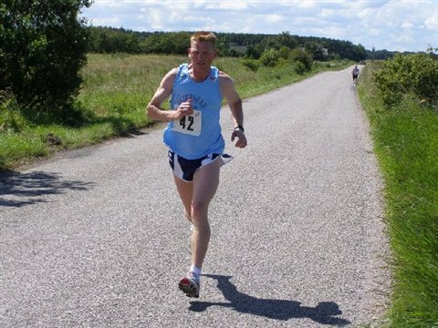

Alan winning the District title at the Elgin 10 miler July 2007

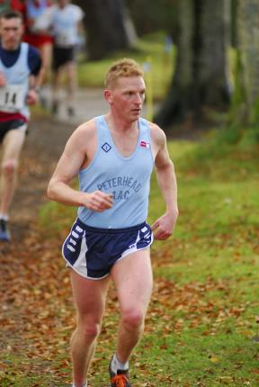

Peterhead to Fraserburgh Beach run,

Alan at the District Champs

Andrew with a Brocher at the Turkey Trot
Shorter Distances
Fragile X 5k, 7 June 2007
1st I Murdoch 16-11, 2nd M Haskett 15-15, 3rd J Matheson 16-20, ... 67th Debbie Hastie 22-38, .. 74th Sandy Hastie 23-10,.. 83rd Ian Duguid 24-11, 110 ran.

Oversea Runs
Terry had several runs 'Down Under'. At the Deepwater Point 15k (4 Nov 07) he was 4th out of 62 (1st C Schmitt 52-57, Terry 54-44). At the John Gilmore State Track Championships 10k (30 Nov 07) he was 8th out of 26 in 34-54 beating the first lady by 2 seconds (1st A Maclean 30-26). On the Western Australia marathon club results sheet they give km averages for each runner, Terry clocked 3-39 for the 15k and 3-29 for his 10k.
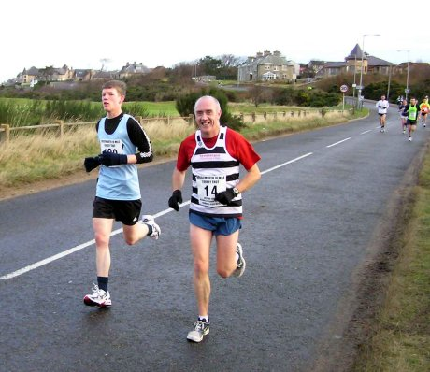

Season bests

 | 5k | 10k | 10 mile | half marathon | marathon
John Bruce |  | 47-06 |  | 103-03
Iain Cruickshank |  | 39-43
Terry Christie |  | 34-54 | 55-29 |  | 3-02-19
Ian Duguid | 24-11 | 51-22
John Diffey
Andrew Grieg |  | 35-51 | 58-05 | 78-45
Debbie Hastie | 22--38 | 49-53
Sandy Hastie | 23-10 | 46-24
Sandy Ingram |  | 43-22
Jamie Mundie
Andy Newlands |  | 41-03
John Robertson |  | 37-46 |  | 81-26 | 3-12-13
Peter Robertson
Alan Reid |  | 33-58 | 54-55 | 73-37 | 2-46-50
Darren Strachan
Stuart Scott
Ann Smith
Duncan Lynch |  | 51-24

John
emails welcome to johninphd@hotmail.com

