Peterhead AAC
April 2000, Update 3 April 2000

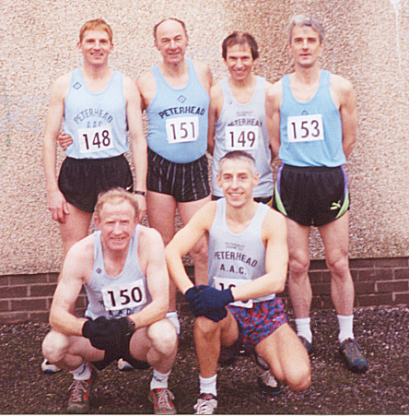
Alan makes it 10!

Alan collected his tenth senior league title, an amazing record.

Final league positions
1st= Alan Reid/Ross Arbuckle (397 points); 3rd A Wright (387). Vet 1 F Barton (400); M Flynn (397); 3 E Paterson (390).

Nairn, 13 January 2000

1 Alan Reid 37-04; 2 R Arbuckle 37-38; 3 A Wright 38-02….27 Iain Cruickshank 44-09

Spean Bridge, 29 January 2000

A 4 lap course, tough up and down with rain, hail stones and strong winds. There were only 29 men ( 3 from the local lochaber club).

1 Alan Reid 34-35; 2 R Arbuckle 35-02; F Barton 36-06……. 17 Ian Cruickshanks 42-11.

Forres, 12 February 2000

Alan had the beating of Simon on the hills but kept getting caught going down – a close tustle that could have gone either way.

1 S Pride 32-02; 2 Alan Reid 32-24; 3 R Arbuckle 32-55……29 Andy Newlands 37-59; ..32 Iain Cruickshank 38-16.

North District Champs, Elgin, 27 Nov. 1999

The results have come through; the Senior race was held up for 30 minutes in freezing conditions so it must go down as the longest ‘warm up’ ever.

The team photograph was taken before this delay and without Iain Cruickshank who was too ill to run.

1 S Pride 38-31; 2 Alan Reid 39-16; 3 R Arbuckle 39-52; ….. 32 Andy Newlands 46-11;… 35 John Robertson 47-14;…42 John Hay 49-23; 43 Ian Duguid 49-27; ..53 John Diffey 54-31.

Cross Country

Scottish Champs, Irvine

1. R Quinn 41-16; 2 T Murray 41-23; 3 G Stewart 41-51……. 43 Alan Reid 45-22.

Cumbernauld, 18 December, 1999

1. S White 25-23; 2 D Bannister 25-24; 3 P Mowbray 25-37…..61 Alan Reid 29-05.

5 k Fun Run in Peterhead

John Diffey organised an informal run/race from his business Riverdale Products in Wilson Street. typical Peterhead weather, wet and windy meant that the turnout was ‘select’. Only Ian Duguid will admit to his time 22min 23s.

Multi Terrain Runs

Millenium Beach Bums
The last beach run of the millenium took place on 27 December. Darren S. ran a sub 2hr (1hr 56min) with Ian D. in a steadier group (2hr 19min 29s). Alan Reid started in Fraserburgh and finished there 34 miles later while Jim Mundie ended up in hospital with sore legs and he only walked!

Speyside Way 50k
Alan Reid sprinted to victory over this scenic route. We collected the 2nd team prize although Iain looked white for many hours after the race until he won the hamper in the raffle!

1 Alan Reid 3-12-20; 2 W Sichel 3-26-54; 3 A Black 3-27-10….13 John Robertson 3-51-20..17 Iain Cruickshank 3-54-23, 81 finished.

On the roads

Inverness half marathon, 12 March
A fast course but it was windy over the last couple of miles
1 S Pride 66-58; 2 M Carroll 68-33; Alan Reid 69-30…. Stuart ……

Nairn 10k
Running into a gale for the first 2 miles caused times to be slow. Darren started steadily and passed other runners continuously. All runners got a Dewar whisky glass rather than a medal
1 S Pride 32-22; 2 M McLeod 33-57; 3 M Turner 34-27….12 Darren Strachan 36-10;…20s John Robertson 37-50.

Elgin 10k
We had a team car upto this race and a supporter car for Darren. The weather was fine and warm. Alan sprinted off at the start but was 10s down on his time to the ‘6 miles to go’ marker.

1 Alan Reid 31-57; R Arbuckle 32-30; M McLeod 33-14… Darren Strachan 35-38…16 John Robertson 36-22…20 Iain Cruickshank 37-38….39 Ian Duguid 41-55 (5th SV); ….64 Ann Smith 46-49 (10th lady).

Fixtures
Date | Event | venue | Contact
30 April | Mar | Lochaber
13 May | 10k | Forres
14 May | 10k | Newtonmore | 01540673203
14 May | 50k | Glenrothes | 01592772771
20 May | 10k | Longside
21 May | 10k | Aberdeen | 01224522190
11 June | half mar | Dyce | 01224485344
2 July | 20k | Portsoy | 01261813383
2 July | half | Stonehaven | 01569768354
30 July | 10 miles | Ballater
26 Aug | Two Bridges | Rosyth | 01383412507
3 Sept | 10k, half, mar | Elgin | 01343551712
17 Sept | 10 miles | Inverness
Prom Spring 3k are on Thurday evenings starting 27 April, continues at Stonehaven on May 4 and back at Aberdeen on May 11.

